Used for UPH, compliments of Dr. Benham (MontClair State University), edited to include MS Excel after 2007

Public-Key Encryption
Since this lab is experiential, you must complete it during the lab period.

When one transmits data over a packet-switched network, like the Internet, a packet sniffer at any node along the transmission path can detect packets with potentially useful information. Unfortunately, some of this information (for example, credit card numbers or other private information) is most useful to people with dishonorable (and often criminal) intentions. As commerce over the Internet – and other vulnerable long-distance networks – increases, this problem becomes more critical. Private data stored on a computer that’s accessible over a network is also vulnerable

One solution to this problem is to encipher data one wants to keep private. In other words, one can somehow “scramble” the data so that it’s unrecognizable to anyone who does not have the necessary key to “unscramble” – or decipher – it. In so-called “traditional” encryption techniques, the same key is used for enciphering (or encryption) and deciphering (or decryption). The key is typically a large number that is used to mathematically transform the message. The problem then becomes the secure transmission of the key itself.
One solution to this problem is to use two different keys – one for encryption and the other for decryption. Alice could then send her encryption key to Bob, who could use it to send an encoded message back to Alice. Provided Alice keeps her decryption key private, no one who intercepts the message will be able to decode it. In fact, Alice could make her encryption key publicly available, so that Carol, David, Egbert, or anyone else who wants to do so can send her an encoded message. So long as she keeps her decryption key secret, no one else will be able to read messages meant only for Alice. For this reason, this type of system is called a public-key encryption system. Often, the encryption key is called the public key, and the decryption key is called the private key.
In this lab, you will be working with a simplified – and not very secure – version of one of the most popular public-key systems: the RSA public-key encryption system. Like all public-key systems, the keys are derived using a “trapdoor” operation – an operation that is easy to do but difficult to “undo.” In RSA, this operation is the multiplication of two large prime numbers: it is easy and fast to multiply the two numbers together, but it is significantly more difficult and time consuming to factor the resulting number back into its prime components. In this lab experience, you will be using relatively small primes (only three digits) to see how this system works.
To explore this system in more depth, you will be exchanging encrypted messages with a partner. Choose your partner now.

- Launch Microsoft Excel and open the spreadsheet
please get file from a shared folder (instructed by your lecturer), file name : rsa.xls.
You may see a warning message informing you that the workbook contains macros. Since you will not need these macros to use the workbook (they are left over from an older and less efficient version of this lab), click on the Disable Macros button.
- This spreadsheet makes use of some specialized functions that are not part of the standard function set in Microsoft Excel. However, they are included in an extra set of functions called the Analysis Toolpak. From the Tools menu, choose Add-Ins…. In the dialogue box, click on the check box to the left of the entry Analysis Toolpak. When a checkmark appears, click on OK. Or if you use MS Excel after 2007 you select File → Options → Add ins (see last page – appendix)
- If necessary, click on the tab for the Key Selection worksheet. Use a random process to choose two different prime numbers p and q between 137 and 311 (displayed in a list in cells g5:I15). Enter these primes in cells B6 and B7. Be sure that cells C6 and C7 both display the message “OK”. The spreadsheet automatically computes the modulus (the product p*q) in cell B8 and the Euler totient (the product (p-1)*(q-1)) in cell B9. Note that the Euler totient would be difficult to determine from the modulus by itself; one needs to know the two primes. Write your two primes, your modulus, and your Euler totient below:
p: 193 q: 263 modulus: 50759
Euler totient: 50304
- Choose a small number (no more that two digits) that has no factors (except 1) in common with the Euler totient. Enter this number as your public key and enter it in cell B15. If cell C15 displays the message Invalid Public Key, you need to select a different public key. When you have chosen a valid public key, the message OK will appear in cell C15. The spreadsheet will automatically compute your private key in cell B20. The private key is chosen so that (Public Key)*(Private Key) leaves a remainder of one when divided by the Euler totient. (This would not be possible if the private had a factor other than 1 in common with the Euler totient.) Write your public and private keys below:
Public key: 13
Private key: 42565
- Once both you and your partner have each created a modulus and pair of keys, you are ready to exchange encrypted messages. Give your modulus and public key to your partner. Do not give your partner your private key or Euler totient. In return, your partner will give you her/his public key and modulus.
- Click on the tab for the Encoding worksheet. Enter your partner’s modulus and public key in cells B6 and B7. Write these values below:
Partner’s modulus: 68269
Partner’s public key: 13
- Enter a message in cell B11. This message should consist of a string of fifteen or more capital letters with no spaces or punctuation marks. The spreadsheet will encipher only the first fifteen letters of your message. Your message could be a short phrase or sentence, your mother’s name or your pet iguana’s name. For example, I used RUTHJULIABENHAM (my mother’s name) and PLEASEHELPMENOW Or other 15 character length words like: JANGANTERLAMBAT, YAAAAHTERLAMBAT, TERLAMBATLAAGII to test this spreadsheet. Note that a message to be enciphered is usually called plaintext. The enciphered form of the message is called the ciphertext.

- The enciphered form of the message (the ciphertext) should appear in cell B13. (This may take a few seconds.) The spreadsheet determines the ciphertext as follows:
- Split the plaintext up into blocks of three letters (called trigraphs).
- Obtain a numeric representation for each letter based on its position in the alphabet (A→0, b→1, etc.).
- Compute a numeric code for each trigraph using the formula
(First Letter Code) * 26² + (Second Letter Code) * 26 + (Third Letter code).
For the mathematically inclined, this is interpreting each trigraph as a number in base twenty-six.
- Encipher each plaintext trigraph code by computing (Plaintext trigraph code)^{Public Key}, dividing the result by the Modulus and taking the remainder.
- Convert each enciphered trigraph code into a quadragraph – a block of four letters – as follows:
- Divide the code by 26^{3.} The quotient is the code for the first letter of the quadragraph. The spreadsheet uses the remainder to get codes for the other three letters.
- Divide the remainder from the first step by 26². The quotient is the code for the second letter. The spreadsheet uses the remainder to get the codes for the other two letters.
- Divide the remainder from the second step by 26. The quotient is the code for the third letter and the remainder is the code for the fourth letter.
For the mathematically inclined, this quadragraph calculation determines the representation of the enciphered message as a four-digit number in base twenty-six (using the letters of the alphabet as our digits).

Some of the details of this calculation appear in cells A16:K38 of the Encoding worksheet. Enter the plaintext and ciphertext below. Show the steps of the conversion process in the table.
Plaintext:NOTHINGNOTHINGS
Plaintext |  | Ciphertext
Trigraph | Trigraph Code | Enciphered Code | Quadragraph
NOT | 9171 | 24683 | BKNJ
HIN | 4953 | 37982 | CEEW
GNO | 4408 | 22174 | BGUW
THI | 13034 | 40981 | CIQF
NGS | 8962 | 10238 | APDU
Ciphertext: BKNJCEEWBGUWCIQFAPDU
- Give the ciphertext (but not the plaintext) to your partner. In return, your partner will give you a ciphertext message. Record the ciphertext message from your partner below. In the rest of this exercise, you will be deciphering this message.
Ciphertext from partner: CIQFBLWKAXJACAHEBBJC
- Click on the tab for the Decoding worksheet. Enter your modulus and your private key in cells B6 and B7 of this worksheet. Enter the ciphertext you received from your partner as the “Encrypted Message” in cell B13. The deciphering process is similar to the enciphering process:

- Split the ciphertext up into quadragraphs (instead of trigraphs).
- Obtain the numeric representation for each letter and compute a numeric code for each trigraph using the formula
(First Letter Code) * 26³ + (Second Letter Code) * 26² + (Third Letter Code) * 26 + (Fourth Letter Code).
Encipher each ciphertext quadragraph code by computing
(Ciphertext quadragraph code)^{Private Key},
dividing the result by the Modulus and taking the remainder

- Convert each deciphered quadragraph code into a trigraph.
- Divide the code by 26². The quotient is the code for the first letter.
- Divide the remainder from the first step by 26. The quotient will be the code for the second letter and the remainder the code for the third.

Note that deciphering uses the private key in place of the public key. Some of the details of this calculation appear in cells A19:D23 of the Decoding Worksheet. The deciphered message should appear in cell B13. Record the results of each deciphering step in the table below.
Ciphertext |  | Plaintext
Quadragraph | Quadragraph Code | Deciphered Code | Deciphered Trigraph
BFRC | 21400 | 6097 | JAN
AWRL | 15325 | 4069 | GAN
AVUT | 14735 | 12965 | TER
BRLD | 29357 | 7448 | LAM
ASQE | 12588 | 695 | BAT
Now, write the deciphered message (plaintext) below.
Deciphered message: JANGANTERLAMBAT
- You need to save the changes, preferably in to the File Server. When you’re finished, please call your lab instructor, so that your work can be confirmed. Now, trace through all RSA calculations from the formulas in the MS Excel file – jot down all the calculations, manual calculation helps us to confirm that the noted formulas are correct.
- Next, is to incorporate your RSA key into the existing Visual Basic Code, until it can encode and decode files.

Appendix
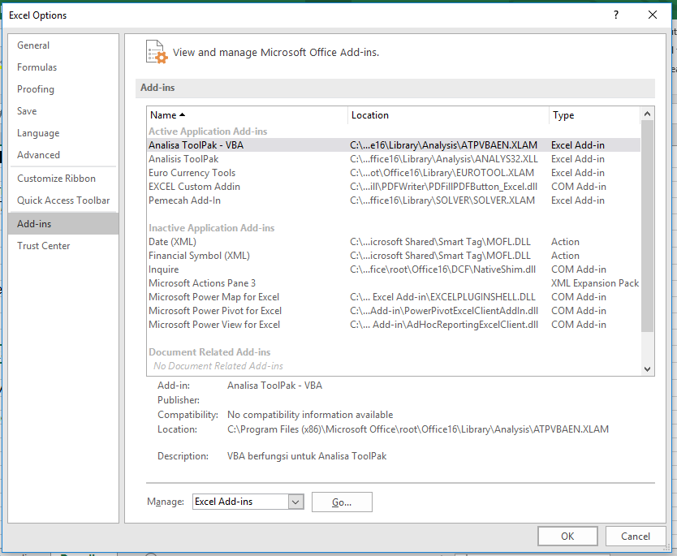

MOD function

This article describes the formula syntax and usage of the MOD function in Microsoft Excel.

Description

Returns the remainder after number is divided by divisor. The result has the same sign as divisor.

Syntax

MOD(number, divisor)

The MOD function syntax has the following arguments:

## Number Required. The number for which you want to find the remainder.
## Divisor Required. The number by which you want to divide number.

Remarks

##If divisor is 0, MOD returns the #DIV/0! error value.
##The MOD function can be expressed in terms of the INT function:
MOD(n, d) = n - d*INT(n/d)

Example

Copy the example data in the following table, and paste it in cell A1 of a new Excel worksheet. For formulas to show results, select them, press F2, and then press Enter. If you need to, you can adjust the column widths to see all the data.

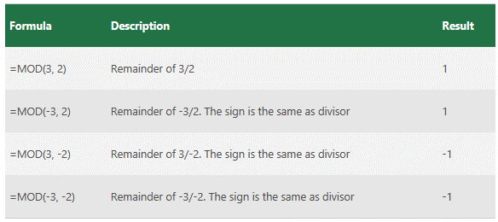

Alice and Bob are the parties to encrypted data exchanges throughout the literature on encryption. If a third party is needed, she’s often named Carol, for some reason.
I’m assuming that Alice is using so-called strong encryption. Otherwise, a cryptanalyst – someone whose profession is breaking codes – who intercepts the message will still be able to decode it.
Named for its inventors – Ron Rivest, Adi Shamir and Leonard Adelman.

